Airbnb Task

Goal : using the 5 tables of the Airbnb data set which indicates rented properties in NYC, combine all to create a single published dataset in in AWS Quicksight.

The resulting data set should include:
- The joined results of 5 tables
- Has no duplicated columns
- Rental Properties that have received at least 250 reviews
- Three property types : entire home, private room, shared room
- Neighbourhood and neighbourhood area
- Price
- Number of Reviews
- Host_ID
It is recommended that you first preview the files in excel to familiarise yourself with the columns you will use for each join.

Steps

Task 1 – create a dataset with the first 2 data sources from uploaded files
- Create a new dataset in QuickSight, by uploading the file Property.csv
- Edit the data set (don’t go straight into publish and visualise)
- Add data, to bring in the next source, another uploaded file – Property_Summary.csv
- Set the join INNER, using ID and PROPERTY_ID
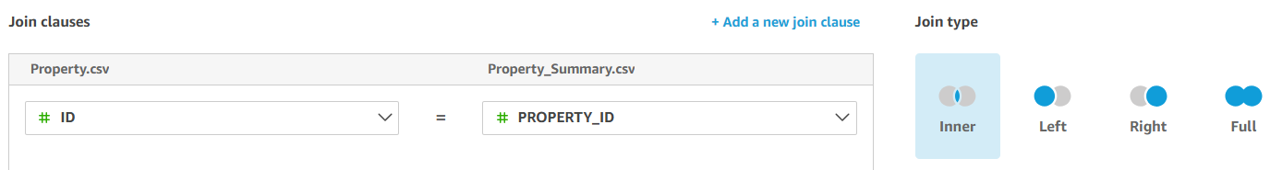

Task 2 - add and join in the remaining tables
- Add data sources to the existing dataset, to pick up the remaining 3 files, ensuring the join type and fields are correctly configured and applied each time.
- The correct joining columns are:
  - Property.ID joins to Property_Summary.PROPERTY_ID
  - Property.PROPERTY_TYPE_ID joins to Property_Type.ID
  - Property.HOST_ID joins to Host.ID
  - Property.NEIGHBOURHOOD_ID joins to Neighbourhood.ID

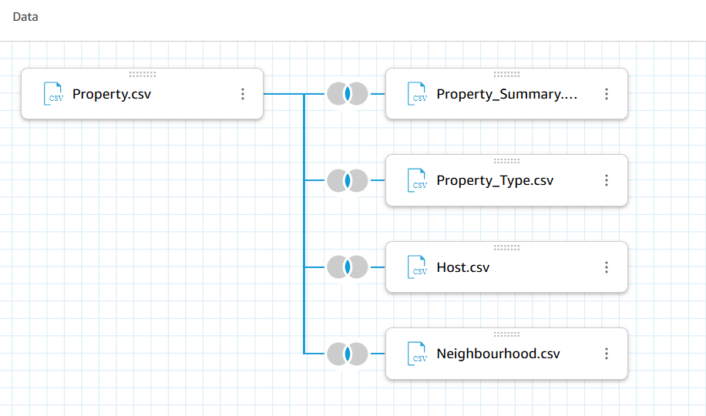
- Confirm after completing the joins that you can see data in your preview. This is an indicator that join matches have been found.

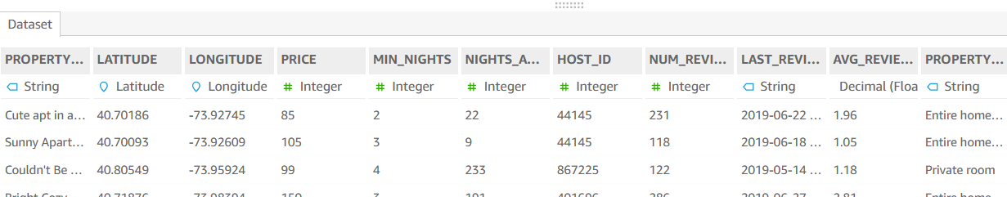

Task 3 exclude columns from the dataset
- Using the 3-dot expansion menu on field names, add all duplicate columns to the Excluded fields pane which the joins have produced. For example, the dataset will contain an ID column in the Neighbourhood.csv file and duplicate Neighbourhood_ID in the Property table.
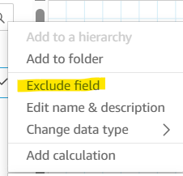
- Any remaining column called simply ID must either be renamed or excluded (the only ID column we will use is the Host_ID)
- Additionally, exclude the field Host_Name to avoid including personally identifiable data in your published dataset.
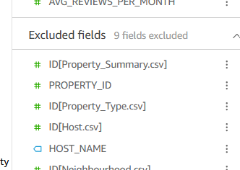

Task 4 exclude rows from the dataset based on a filter
- Using filters menu on the left-hand side of the UI, add a data source filter on the column NUM_REVIEWS that restricts the dataset to only those properties that have gained at least 250 reviews. This will restrict the number of rows you load into SPICE and make subsequent changes to your dataset quicker to process.
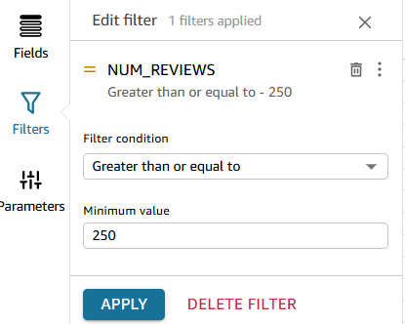

Task 5 Publish your data set and Visualise
- Choose to publish and visualise your dataset, before constructing a scatter plot which shows:
  - Average Price of the rental
  - Median number of Reviews for the rental
  - Per Property Type, Neighbourhood_Area and Neighbourhood
  - With an indicator of which value within each category has the most hosts
- Note that if you have not applied the filter in Task 4, your plot will display only a portion of your data (up to 2500 records) which is due to a system imposed display limit in QuickSight. This is because of the compute resource required to display such detail.

